**IAM (Identity and Access Management)**

**Pramila Jadhav**

1. **Create IAM user name “mayuri” assign iamfullaccess policy document from GUI, download excel file.**

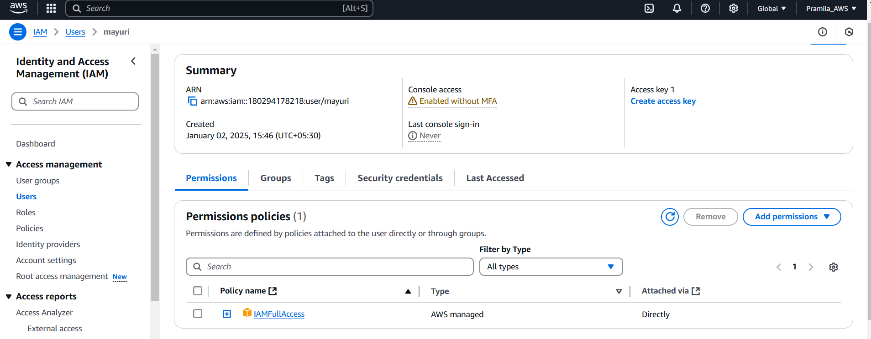

1. **Login with mayuri from aws console and try to create ec2 instance**

**Login with mayuri from aws console**

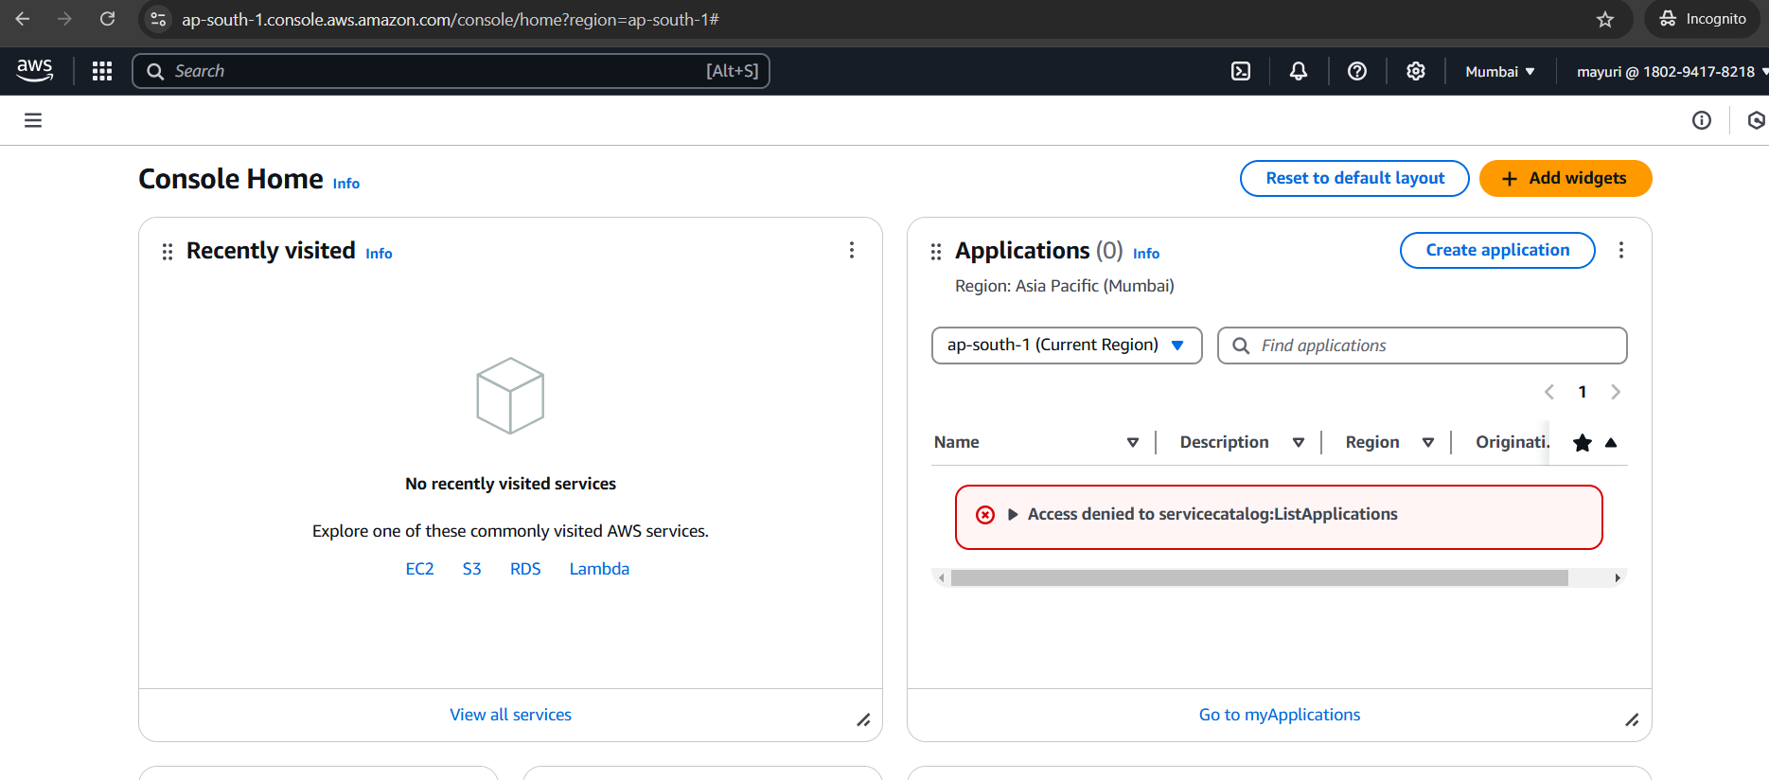

**Try to create ec2 instance –**

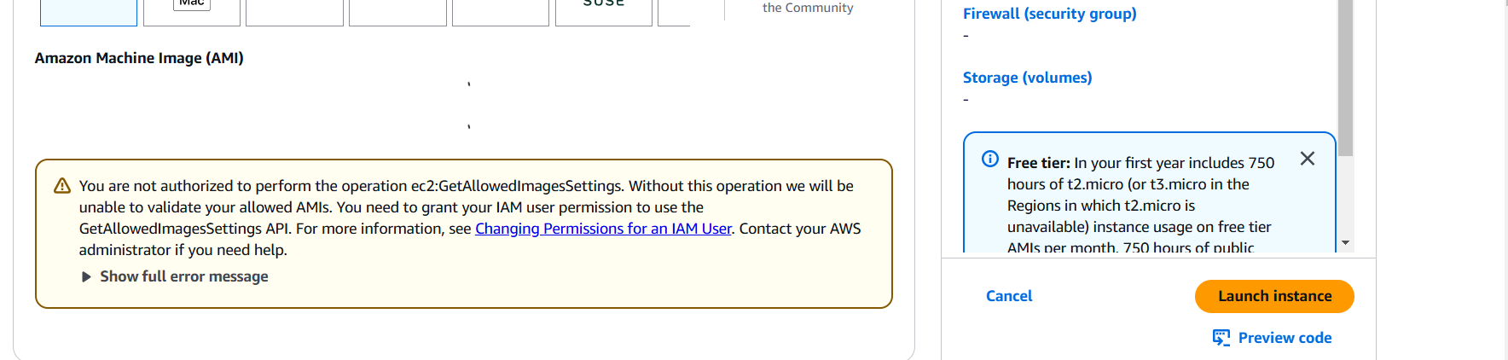

1. **Assign ec2fullaccess policy document to user “mayuri” and try to create ec2 instance with tag key = name value =webserver**

**Assign ec2fullaccess policy document to user “mayuri**

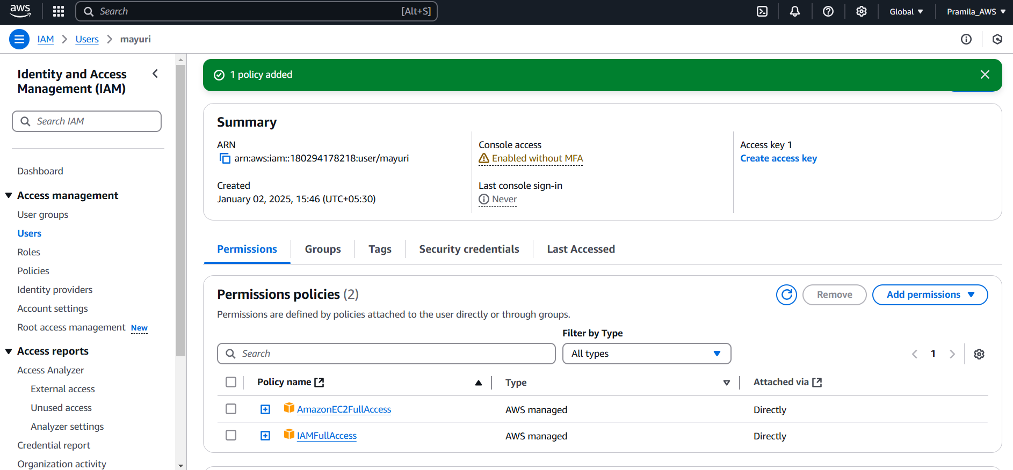

**Create ec2 instance with tag key = name value =webserver**

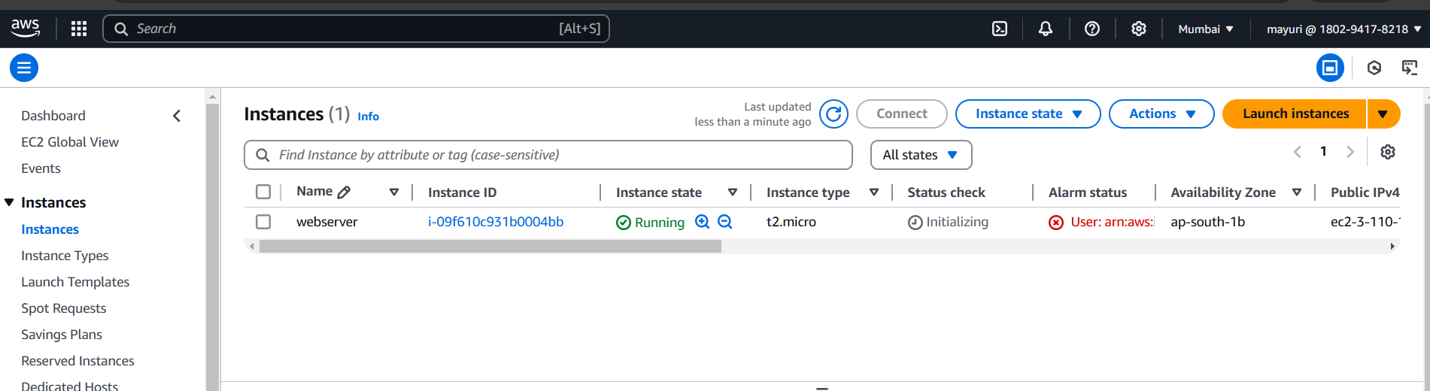

1. **Create a role ‘manishaiamadmin’ and assign iamfullaccess policy document to role**

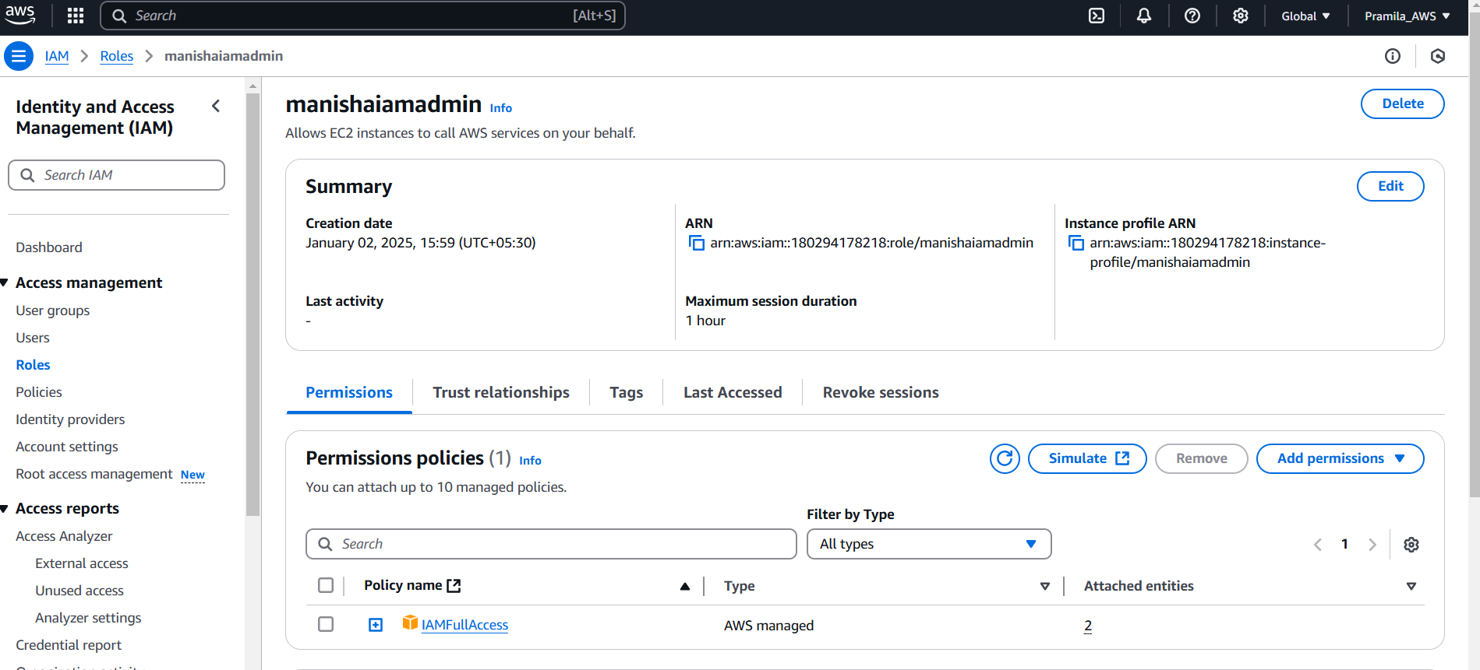

1. **Assign the role to running instance “webserver”**

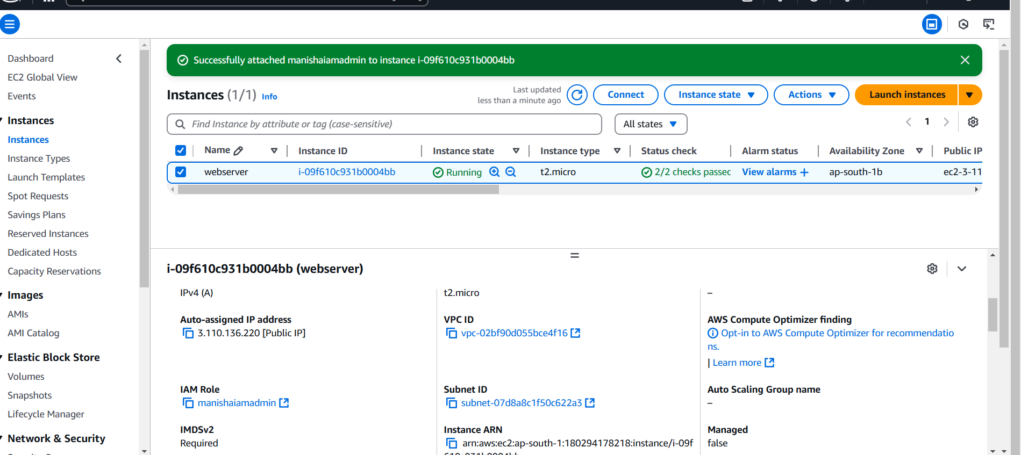

1. **Login instance with public IP and Private key**

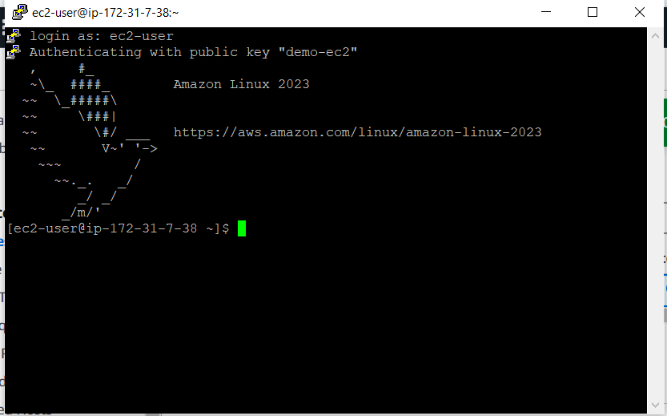

1. **Create a aws IAM user from the instance**

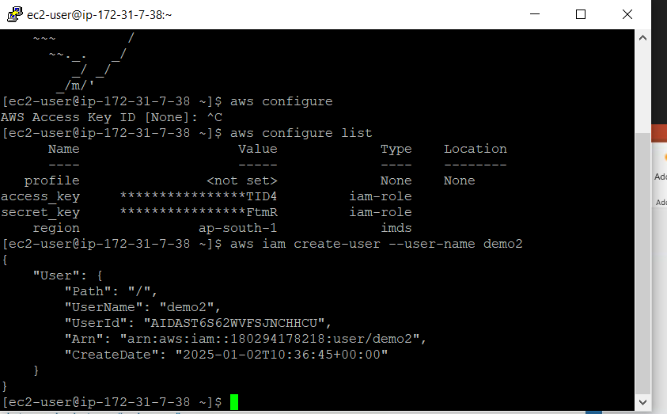

1. **Slide 14**

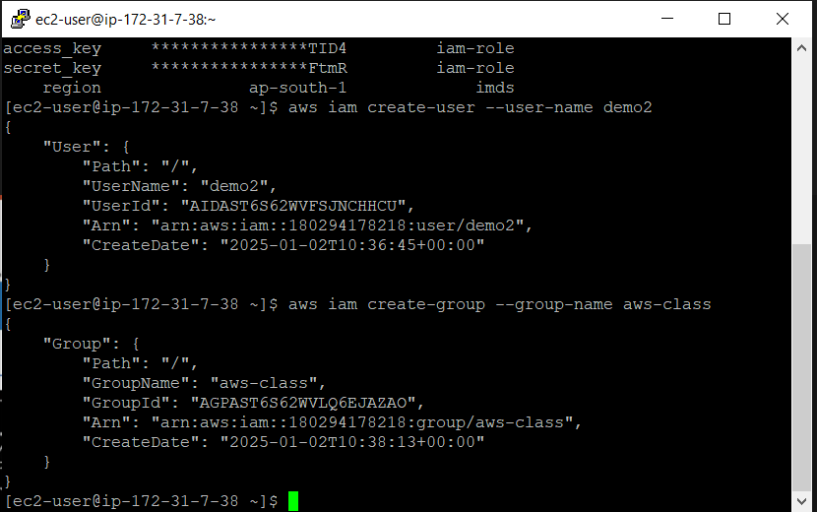

1. **Remove role iamrole from the instance “webserver” which has attached**

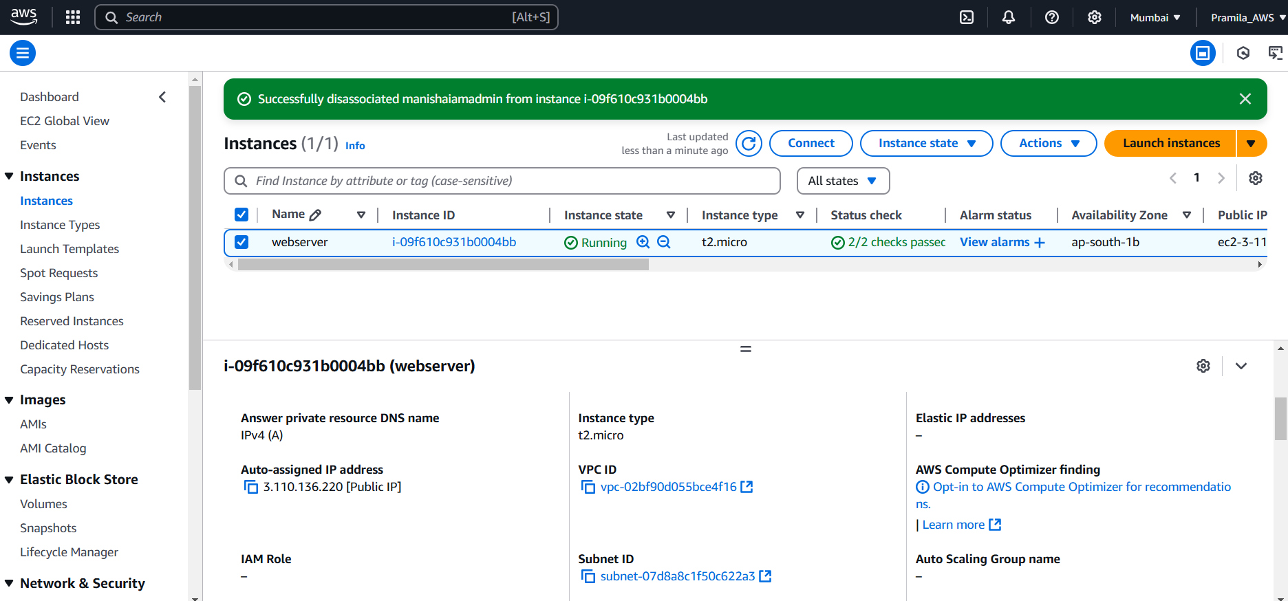

1. **Create iam user again, not able to create as iam role is removed**

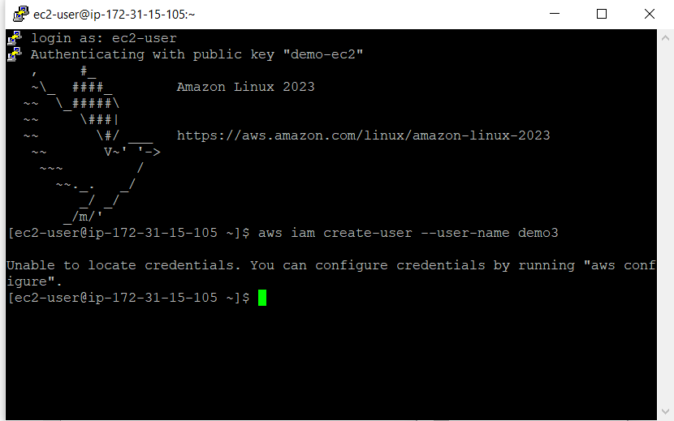

1. **Configuring iam aws user to work from cli**

